**CHAPTER 1**

**INTRODUCTION**

* 1. **About the project**

Civil registration is the system by which a government records the vital events of its citizens and residents. The resulting repository or database is called civil register or registry, or population registry. The primary purpose of civil registration is to create legal document that are used to establish and protect the civil rights of individuals. A secondary purpose is to create a data source for the compilation of vital statistics in most countries; there is a legal requirement to notify the relevant authority of any life event which affects the registry.

The United Nations defines registration as “the continuous permanent compulsory and universal recording of the occurrence and characteristics of vital events pertaining of the population as provided through decree or regulation in accordance with the legal requirements of a country.

Civil registration is carried out primarily for the purpose of establishing the legal documents provided by the law. These records are also a main source of vital statistics. Complete coverage, accuracy and timelines of civil registration are essential for quality vital statistics.

Vital events that are typically recorded include live birth, death, marriage, divorce, annulment of marriage, judicial separation of marriage, adoption, legitimization and recognition. Additionally, in some countries, immigration, emigration, and any change of residence may require notification. Among the legal documents that are derived from civil registration are birth certificates, death certificates and marriage certificates.

Civil Registry is the online system or agency to help the Indian citizens to apply for there government records like passport, driving license, voter’s ID card, PAN card etc. And register certificates like birth, death, marriage etc.

The primary objective of this web site is to give awareness about the government or legal documents and its registration details as well as to help to register or apply for those documents. This also acts as a consultancy agency to assist the public. The main purpose of the web site is to reduce the effort by the candidate and save his time and avoid unwanted rushes at the government offices and assure a smooth working schedule at government offices.

The project Civil Registry still requires more development of IT solution and its applications to improve the issuance of copies of government certificates and legal documents. Civil registry team trying to get more affiliation to government offices and departments. Now civil registry team acting as an agency to help the public.

* 1. **Plan of the Report**

In order to endow with a view on the project, the report has been organized according to the development stages it brings out all that was accomplished to implement the project. The plan of the report is as follows:

Chapter 2-“Problem Definition and Feasibility Analysis “gives a brief defining of the problem persisting and various feasibility measure needed to be adopted to solve the problem.

Chapter 3-“Software Requirement Specification” discusses the stated problem, the purpose and scope of the application to be developed, existing system with its limitation and a general description of the desired solution.

Chapter 4, 5-“System Design” discusses the various design issues such as Preliminary design, detailed and Physical and System architecture.

Chapter 6-“Coding Implementation and Testing “discusses about the client side testing, server side testing and their implementation.

Chapter 7-“Conclusion and Future Enhancement” discuss the concluding remarks and possibility by which the application can be enhanced.

**CHAPTER 2**

**PROBLEM DEFINITION AND FEASIBILITY ANALYSIS**

**2.1 Introduction**

The first step involved in the development of this project is that the user’s requirement was acquired and the existing system was studied carefully, and the persisting problem faced by the users of system was analyzed. After analyzing the existing system and its short comings, a new system has been proposed which satisfied the user’s requirements as well as removes the problem due to the existing system.

Problem definition and Analysis Phase is the backbone for the software to be developed. The process of the system analysis involved gathering of facts and figures required in the development of the project.

**2.2 Problem Definition**

The manual system of Civil Registration is really tedious and time consuming. As it requires huge number of papers and manpower, obviously, it is uneconomical as well. For a simple birth or death registration, one has to waste whole day to visit the government office. In order to overcome these drawbacks of manual system, proposed system is designed to work online which can be browsed from anywhere. As the use of computer and internet is rapidly growing all over the world, the computerized system are more preferred and expected to be more efficient. This proposed project is a similar highly efficient computerized web-based software.

**2.2.1 Existing system**

The present Civil Registry System does not consist an automated process but work with the manual method. A person who wants to know the details about any government documents or registration has to visit the government office. The person has to spend time in office and has to visit different sections of the department which are a highly time-consuming process. There is no system by use of which a user can know the status of the applied documents. A person faces many problems during the government related work.

**Drawbacks of the existing system**

There are several disadvantages and following or the drawbacks that are caused by the existing system

* Hard to Make Changes
* Access Time
* Lack of Security
* Higher Cost
* Security issues in User Data.

**2.2.2 Proposed System**

In the proposed Civil Registry System the public can use the online website and can know the details about the process required to make the documents like PAN card, Adhar Card. The user can also know about the details regarding the registration of property, birth, marriage, death, etc. as well the users can apply for the documents and do the registration from the system itself. The users can also know the status of the applied documents through the system. The Civil Registry System will keep the information provided by the user for the next time. This system will reduce the time consumption in the process and will make all the process easy for the public.

**Advantages in the proposed system are**

* It helps the government in computerization of civil registration procedure and digitalization of official cards such as citizenship, ration card, voter card, etc.
* It reduces the manual official works, and is less time consuming.
* It can be browsed easily from anywhere with the facility of internet access.
* It reduces the use of papers and workers in government offices. So, it improves the economic condition of government offices.

**2.3 Feasibility Analysis**

The feasibility study is major factor which contributes to analysis of system. In earlier stages of software development, it is necessary to check whether system is feasible or not. Detail study was carried out to check workability of proposed system, so the feasibility study is system proposal regarding to its workability, impact on organization, ability to meet user requirements and effective use of resources. Thus, when application progresses it normally goes through a feasibility study and risk analysis.

Feasibility study was carried out considering the following aspects:-

There are different ways of checking whether a system is feasible or not, but some of the most important tests are the following:-

* Economic Feasibility
* Technical Feasibility
* Operational Feasibility

The last three feasibility studies are made for almost all types of projects and in particular application and system projects. If the three feasibility studies are carried out successfully and properly, a clear picture of the project can be got before developing the project itself.

**2.3.1 Economical Feasibility**

Economic feasibility determines whether the required software is capable of generating financial gains for an organization. It involves the cost incurred on the software development team, estimated cost of hardware and software, cost of performing feasibility study, and so on. For this, it is essential to consider expenses made on purchases (such as hardware purchase) and activities required to carry out software development. In addition, it is necessary to consider the benefits that can be achieved by developing the system.

**2.3.2 Technical Feasibility**

Technical feasibility assesses the current resources and technology, which are required to accomplish user requirements in the software within the allocated time and budget. For this, the software development team ascertains whether the current resources and technology can be upgraded or added in the software to accomplish specified user requirements. Technical feasibility also performs the following tasks.

• Analyzes the technical skills and capabilities of the software development team members.

• Determines whether the relevant technology is stable and established.

• Ascertains that the technology chosen for software development has a large number of users so that they can be consulted when problems arise or improvements are required.

**2.3.3 Operational Feasibility**

Operational feasibility assesses the extent to which the required software performs a series of steps to solve business problems and user requirements. This feasibility is dependent on human resources (software development team) and involves visualizing whether the software will operate after it is developed and be operative once it is installed. Operational feasibility also performs the following tasks.

• Determines whether the problems anticipated in user requirements are of high priority.

•Analyzes whether users will adapt to a new software.

• Determines whether the organization is satisfied by the alternative solutions proposed by the software development team.

**2.4 Recommended Implementation**

Taking the above-mentioned factors into consideration, the proposed system has been considered as feasible and recommend for implementation. After careful analysis of the system, the following facts are found. The major functionalities are identified in the system and hence the system can be categorized into many sub system and modules. Each operation in the sub system is treated as a separate module that differs from other but interact with each other.

**CHAPTER 3**

**SOFTWARE REQUIREMENT SPECIFICATION**

**3.1. Introduction**

The purpose of this Software Requirements Specification is to produce at the zenith of the analysis task. The introduction of this document states the overall goals and objectives of the software product, describing it in the context of the computer-based system. This document also tells the software scope of the planning document.

Software Requirement Specification is basically an organization understanding of a customer or potential clients system and dependencies at a particular point in time prior to any actual design or development work. Software Requirement Specification has been developed for future reference in case of any ambiguity and misunderstanding. Software Requirement Specification provides a detailed of the requirements, behaviors, constraints and performance of the system.

The goal of software requirement specification is to completely and consistently specify the technical requirements for the software product in a concise and an unambiguous manner.

Requirement analysis if for transformation of operational need into software description, software performance parameter, and software configuration through use of standard, iterative process of analysis and trade-off studies for understanding what the user wants analyzing need, assessing feasibility, negotiating a reasonable solution validating the specification and managing the requirements.

**3.1.1 Objective**

  It offers **benefits** such as reduced **costs** and complexities, better agility etc. However, your business needs to identify and decide upon security challenges, transparency needs, availability and integration has to be carefully balanced.

**3.2 Functional requirements**

Functional requirements explain what must be done by identifying the necessary task, action or activity that must be accomplished. Functional requirements analysis will be used as the top-level functions for functional analysis.

**3.2.1 Usability**

Usability is the degree to which software can be used by specified consumes to achieve quantified objectives with effectiveness, efficiency and satisfaction in quantified context of use.

**3.2.2 Maintainability**

Maintainability basically defines that how easy it is to maintain the system. This means that how easy it is to analyze, change and test the application. Maintainability of the project is simply as further updates can be easily done without affecting its stability.

**3.2.3 Compatibility**

Compatibility of this project is worldwide. It is a web application and is supported by all the web browsers.

**3.2.4 Functionality**

The system provides multiple functionality likes Time Allotment, Server Overloaded, Cloud Server Notification, Multiple Deadlines, User Notification and File Retrieval.

**3.2.5 Efficiency**

Efficiency the amount of resources required by a program to perform a specific function. This term is used to show the effort put in to develop the application and to quantify its user-satisfaction.

**3.2.6 Security**

Security is a specialized field that focuses on the security aspects in the design of systems that need to be able to deal robustly with possible sources of disruption, ranging from natural disasters to malicious acts.

**3.2.7 Safety**

  Safety is a risk management strategy based on identification, analysis of

Hazards and application of remedial controls using a systems-based approach.

**3.3 Non-Functional Requirements**

**3.3.1 Security**

The state of providing access to resource is security. The system provides sad security and authorized user cannot access the system thereby providing separate login to admin. Only authenticated user can access data there by maintaining high security.

**3.3.2 Portability**

It is the usability of the same application in different environment. The web application can be run on any browser.

**3.3.3 Performance**

These requirements determine the resources required that deals with the performance of the system.

**3.3.4 Flexibility**

The flexibility of the project is provided in such a way that is has the ability to run on different environments being executed by different users.

**3.4 Software Analysis**

**3.4.1 Hardware Requirements**

* Speed : 2 GHz core CPU.
* RAM :  4 GB RAM or above.
* Hard Disk     : 500 GB HDD.
* Processor  : Intel i3 and above processor.

**3.4.2 Software Specification**

* Microsoft account : Visual Studio
* Operating System : Windows
* Front End **:** Asp.net,HTML5,CSS3
* Back End  :MSSQL

**CHAPTER 4**

**SYSTEM DESIGN – PRELIMINARY**

**4.1 Introduction**

System design is the process of planning the software product. The design is the process of applying various techniques and principles for the purpose of defining a process or a system in sufficient detail. The design acts as a link between the actual problem specification and the actual implementation.

The high level design document will help to understand the system more clearly and the basis of this document, detailed design of the system can be done. It will give a high level view of the functionalities described in the Software Requirement Specification. The overall design of the Remote Monitoring and Network Administration System is divided into two segments

* Preliminary Design
* Detailed Design

**4.2 Basic Design Approach**

A project is developed to solve a problem where the developer or a software engineer has to follow a certain development strategy. This strategy incorporates process, methods and tools used in the project. This strategy is known to be as a process model or a software engineering paradigm. A project model is begin preferred by the nature of the project and the application.

The Visual Studio IDE (integrated development environment) is a software program for developers to write and edit their code. Its user interface is used for software development to edit, debug and build code. Visual Studio includes a code editor supporting IntelliSense (the code completion component) as well as code refactoring. The integrated debugger works both as a source-level debugger and a machine-level debugger. Other built-in tools include a code profiler, designer for building GUI applications, web designer, class designer, and database schema designer. 

**4.2.1 Modules Design**

This project “CIVIL REGISTRY SYSTEM” deals with Data Storage for application. This contains the following modules.

* Admin
* Agent
* Users

The entire project is divided into 3 modules.

* + - 1. Users
* Login: The user will need to enter the ID and password in the website to use the system with their profile.
* Register: The users need to register into the system. During the registration, the users need to provide the information to the system.
* Details: The user will get the information about all the government document through this module.
* Apply: The user can apply for the document by use of this document.
* Help: This module will provide the information about how they can apply for different documents from the system.
* Save: If a user wants to keep the data on the website, can save the different information to the system. The user can use these saves data for later use.
  + - 1. Agent
* Login: The agent will need to enter the ID and password in the website to use the system with their profile.
* Details: The user will get the information about all the government document through this module.
* Approved: The agent check the user request and fill all required field it can be apply for the government website.
* Help: This module will provide the information about how they can apply for different documents from the system.
* Save: Agent wants to keep the data on the website, can save the different information to the system. The user can use these saves data for later use.

4.2.1.3 Admin

* Login: The admin will need to enter the ID and password in the website to use the system with their profile.
* Register: The agent need to register into the system. During the registration, the users need to provide the information to the system. So the admin create an id and password of agent based on the working location.
* Details: The user will get the information about all the government document through this module.
* Report: The admin can see the all the reports of this application. And verified all works.
* Export report: If an Admin wants to keep the data on the website, can save the different information to the system. The admin can use these saves data for later use.
  1. **Design Concepts**

**4.3.1 Modularity**

The concept of modularity in computer software has been exposed for almost three decades. The software architecture embodies modularity; i.e. software is divided into separately named and addressable, often called modules which are integrated to satisfy the problem requirements. Modularity is the single attribute of the software that allows a program to be intellectually manageable.

The fundamental goal of the design is to reduce the number if complexities of interconnections between the functionalities. Effective modularity means by high cohesion and low coupling.

**4.3.2 Coupling**

Coupling is the measure of relative interdependence among modules. Coupling is a measure of interconnection among modules in a software structure. Coupling depends on the interface complexity between modules and the point at which entry or reference is made to a module, and what data pass across the interface. In a software design low coupling must be achieved.

Coupling is the relationship between the modules of the system. All the sub-modules are coupled with their corresponding main module. Where there is a tradeoff between redundancy and the degree of coupling, reducing coupling was given the priority. Since some data is exchanged between modules, low coupling called data coupling exists.

In this project, modules are coupled together to the major modules. For instance, in order to export contacts the required fields can retrieve from the respective tables. Some data is shared between the modules where the exchange may takes place to improve the efficiency.

**4.3.3 Cohesion**

Cohesion is the measure of the relative functional strength of an individual module. It is a natural extension of the information hiding concept. A cohesive module performs a single task with in a software procedure, requiring little interaction with procedures being performed in other parts of a program.

It should be as high as possible for the system to function efficiently. Care is taken for the modules to be as cohesive as possible. As the modules perform tasks that are related logically in each module, logical cohesion exists and since processing elements in a module are related and executed in a specific order, procedural cohesion exists.

* 1. **User Interface Design**

The user identification and the interaction between the user and the computer system are dealt in the user interface design. Proper input validation is provided with a precise and unambiguous message to correct the input for the user.

* Appropriate warning and error messages have to be provided to guide the user, throughout the application.
* Easy to understand the navigation.
* Easy to view.

**CHAPTER 5**

**SYSTEM DESIGN – DETAILED**

**5.1 Introduction**

System Design specifies the overall functions and interaction between various subsystems. In detailed design, functions of each and every module are explained with appropriate description and specifying the tables referenced and updated.

**5.2 Software Modules Purpose and Description**

A module is a separate unit of software or hardware. Typical characteristics of modular components include portability, which allows them to be used in a variety of systems, and interoperability, which allows them to function with the components of other systems. The term was first used in architecture.

**5.2.1 Admin Module**

The admin will need to enter the ID and password in the website to use the system with their profile. The admin need to register an agent details and generate an id and password into the system. During the registration, the users need to provide the information to the system. So the admin create an id and password of agent based on the working location. The user will get the information about all the government document through this module. The admin can see the all the reports of this application. And verified all works. Such as user apply a civil register application and agent work. If an Admin wants to keep the data on the website, can save the different information to the system. The admin can use these saves data for later use such as csv file.

**5.2.2 Agent Module**

The agent will need to enter the ID and password in the website to use the system with their profile. The agent will get the information about all the government document through this module. The agent check the user request and fill all required field it can be apply for the government website. And sent the approved notification through email conversation. This module will provide the information about how they can apply for different documents from the system. Agent wants to keep the data on the website, can save the different information to the system. Use these saves data for later use.

**5.2.3 User Module**

The user will need to enter the ID and password in the website to use the system with their profile. The users need to register into the system. During the registration, the users need to provide the information to the system such as email, username and password. The user will get the information about all the government document through this module. The user can apply for the certificate based on the user whatever need by use of this document. This module will provide the information about how they can apply for different documents from the system. A user data to keep on the website, can save the different information to the system.

**5.3 Input Design**

The input design is the link that information system to the world of its users. It consists of depending specification and procedures for data preparation and to input into the computer for processing. Simply the input design is the process of converting the user generated inputs into computer based format. The input screen is not over crawled, as the user can understand a piece of information from the screen. Instead more are provided to understand the data entry process.

* The input validation is being done at program level to check errors and help message are to be provided to effectively data entry into data entry screen into the software
* As human is prone for errors and mistake confirmation for critical data entries are being provided.

**5.4 Output Design**

The design of output is the most important task of any system. During output design, developers identify the type of outputs needed, and consider the necessary output controls and prototype report layouts.

System design is the process by which a logical model of the proposed system is designed using the system flow diagram, dataflow diagram. Using these tools, the input to the system, system flow, dataflow the output of the system and the files to be used and designed.

**5.5 Exception Handling**

The **Exception Handling** is one of the powerful mechanism to handle the runtime errorsso that normal flow of the application can be maintained. In case of exception, appropriate message are provided to the user without abruptly sending the exception.

In this system, when an exception occurs, the normal execution of the program is affected. So proper care has been taken to handle these types of errors. Whenever necessary, proper checking is done for exception condition. In Case of such exception appropriate message are provided to the user without abruptly suspending the execution

**5.6 Security**

The data is secured within data centres and where some countries require data to be stored in their country, choosing a provider that has multiple data centres across the world can help to achieve this.

Data storage often includes certain compliance requirements especially when storing credit card numbers or health information. Many cloud providers offer independent third party audit reports to attest that their internal process exist and are effective in managing the security within their facilities where we can store the data.

**CHAPTER 6**

**CODING IMPLEMENTATION AND TESTING**

**6.1 Implementation**

The “CIVIL REGISTERY SYSTEM” has been done with the test data. This system is implemented to many tests and its performance is good. This system provides many features in traders and users. This system is very useful for overall global traders. Communication is fast and efficient and consistent.

**6.2 Testing**

Testing is the major quality control measure employed during software development. Its basic function is to detect errors. Testing is the process of executing a program with the intention of finding errors. It is a complete verification to determine whether the objectives are met under the user requirements or satisfied. After the coding face, testing is done to test the working of the new system. Testing represents the ultimate review of specification, design and coding. Thus, the goal of testing is to undercover the requirements, design and coding errors in the program.

Software testing is any activity aimed at evaluating an attribute or capability of a program or system under determining that it meets its record results. Testing is more than just debugging the purpose of testing can be quality assurance, verification under validation or reliability estimation. System testing is actually a series of different tests whose primary purpose is to fully exercise the Computer based system.

**6.2.1 Unit Testing**

It focuses on the smallest unit of software design. In this, we test an individual unit or group of interrelated units. It is often done by the programmer by using sample input and observing its corresponding outputs. Developers also work with mock objects and virtualized services to make sure their units can be tested independently.

**6.2.2 Integration Testing**

The objective is to take unit tested components and build a program structure that has been dictated by design. Integration testing is testing in which a group of components is combined to produce output.

**6.2.3 Regression Testing**

Every time a new module is added leads to changes in the program. This type of testing makes sure that the whole component works properly even after adding components to the complete program.

**6.2.4 System Testing**

This software is tested such that it works fine for the different operating systems. It is covered under the black box testing technique. In this, we just focus on the required input and output without focusing on internal working. In this, we have security testing, recovery testing, stress testing, and performance testing.

**6.2.5 Functional Testing**

It is a type of software testing that validates the software system against the functional requirements/specifications. The purpose of Functional tests is to test each function of the software application, by providing appropriate input, verifying the output against the Functional requirements. Functional testing mainly involves black box testing and it is not concerned about the source code of the application. This testing checks User Interface, APIs, Database, Security, Client/Server communication and other functionality of the Application under Test.

**6.3 Result and Discussion**

Our proposed system which provides to learn an effective latent representation, we simultaneously incorporate prior knowledge, such as temporality of wellness features a erogravity of users. Essentially, that allows an authorized data user to apply for certificate in a privacy-preserving manner.

**CHAPTER 7**

**CONCLUSION AND FUTURE ENHANCEMENT**

**7.1 Conclusion**

You can find detailed description of Civil Registration System in the project report available in the download file. To conclude, this project computerizes the various registration system in government offices and digitalizes the official cards provided to the citizens. The growing use of internet and the current uneconomical, time consuming manual registration system makes up for the good scope of this web-based project.

**7.2 Future Enhancement**

Demonstrate that India’s CRS has major strengths in infrastructure, reporting coverage, data completeness and management. In several states, these strengths also translate into more reliable CRS-based adult mortality risks than those from the SRS, hence establishing reliable mortality baseline measures for monitoring non-communicable disease mortality at state and district level in India. Looking forward, there appears to be sufficient political will and support for further reforms to strengthen local registration and statistical operations, as well as to improve this system in all certificate and need to improve all district of Tamilnadu in the form of recent government regulations on these subjects. All these observations indicate that with appropriately designed system strengthening initiatives, the Indian CRS could be able to serve its goal as a reliable source for national and subnational vital statistics in the near future.

**BIBLIOGRAPHY**

**BOOKS**:

* Paramjeet Kaur, (2021) “Registration Act “Edition: 1st.
* Krishna Kumar, Nandita Saikia, Nadia Diamond-smith(2020) “Performance barriers of Civil Registration System in Bihar: An exploratory study”
* Bethesda, Maryland U.S.A, (Oct-1983) “STUDY OF A CIVIL REGISTRATION SYSTEM OF BIRTHS AND DEATHSAN EXPERIMENT IN AFGHANISTAN”

**WEBSITES**:

* https://www.who.int/data/data-collection-tools/civil-registration-and-vital-statistics-(crvs)
* https://gh.bmj.com/content/5/8/e002586
* https://www.dailypioneer.com/2022/columnists/crs-is-a-vibrant--robust-exercise-crs-is-a-vibrant--robust-exercise.html

APPENDIX A-DIAGRAM

**OVERALL DESIGN**

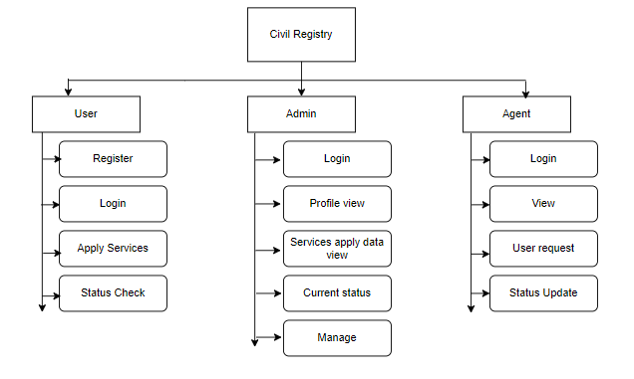3CmxGraphModel%3E%3Croot%3E%3CmxCell%20id%3D%220%22%2F%3E%3CmxCell%20id%3D%221%22%20parent%3D%220%22%2F%3E%3CmxCell%20id%3D%222%22%20value%3D%22Civil%20Registry%22%20style%3D%22rounded%3D0%3BwhiteSpace%3Dwrap%3Bhtml%3D1%3B%22%20vertex%3D%221%22%20parent%3D%221%22%3E%3CmxGeometry%20x%3D%22360%22%20y%3D%2221%22%20width%3D%22120%22%20height%3D%2260%22%20as%3D%22geometry%22%2F%3E%3C%2FmxCell%3E%3CmxCell%20id%3D%223%22%20value%3D%22User%22%20style%3D%22rounded%3D0%3BwhiteSpace%3Dwrap%3Bhtml%3D1%3B%22%20vertex%3D%221%22%20parent%3D%221%22%3E%3CmxGeometry%20x%3D%22120%22%20y%3D%22120%22%20width%3D%22120%22%20height%3D%2240%22%20as%3D%22geometry%22%2F%3E%3C%2FmxCell%3E%3CmxCell%20id%3D%224%22%20value%3D%22Admin%22%20style%3D%22rounded%3D0%3BwhiteSpace%3Dwrap%3Bhtml%3D1%3B%22%20vertex%3D%221%22%20parent%3D%221%22%3E%3CmxGeometry%20x%3D%22360%22%20y%3D%22120%22%20width%3D%22120%22%20height%3D%2240%22%20as%3D%22geometry%22%2F%3E%3C%2FmxCell%3E%3CmxCell%20id%3D%225%22%20value%3D%22Agent%22%20style%3D%22rounded%3D0%3BwhiteSpace%3Dwrap%3Bhtml%3D1%3B%22%20vertex%3D%221%22%20parent%3D%221%22%3E%3CmxGeometry%20x%3D%22600%22%20y%3D%22120%22%20width%3D%22120%22%20height%3D%2240%22%20as%3D%22geometry%22%2F%3E%3C%2FmxCell%3E%3CmxCell%20id%3D%226%22%20value%3D%22Register%22%20style%3D%22rounded%3D1%3BwhiteSpace%3Dwrap%3Bhtml%3D1%3B%22%20vertex%3D%221%22%20parent%3D%221%22%3E%3CmxGeometry%20x%3D%22150%22%20y%3D%22170%22%20width%3D%22120%22%20height%3D%2240%22%20as%3D%22geometry%22%2F%3E%3C%2FmxCell%3E%3CmxCell%20id%3D%227%22%20value%3D%22Login%22%20style%3D%22rounded%3D1%3BwhiteSpace%3Dwrap%3Bhtml%3D1%3B%22%20vertex%3D%221%22%20parent%3D%221%22%3E%3CmxGeometry%20x%3D%22150%22%20y%3D%22220%22%20width%3D%22120%22%20height%3D%2240%22%20as%3D%22geometry%22%2F%3E%3C%2FmxCell%3E%3CmxCell%20id%3D%228%22%20value%3D%22Apply%20Services%22%20style%3D%22rounded%3D1%3BwhiteSpace%3Dwrap%3Bhtml%3D1%3B%22%20vertex%3D%221%22%20parent%3D%221%22%3E%3CmxGeometry%20x%3D%22150%22%20y%3D%22270%22%20width%3D%22120%22%20height%3D%2240%22%20as%3D%22geometry%22%2F%3E%3C%2FmxCell%3E%3CmxCell%20id%3D%229%22%20value%3D%22Status%20Check%22%20style%3D%22rounded%3D1%3BwhiteSpace%3Dwrap%3Bhtml%3D1%3B%22%20vertex%3D%221%22%20parent%3D%221%22%3E%3CmxGeometry%20x%3D%22150%22%20y%3D%22320%22%20width%3D%22120%22%20height%3D%2240%22%20as%3D%22geometry%22%2F%3E%3C%2FmxCell%3E%3CmxCell%20id%3D%2210%22%20value%3D%22Profile%20view%22%20style%3D%22rounded%3D1%3BwhiteSpace%3Dwrap%3Bhtml%3D1%3B%22%20vertex%3D%221%22%20parent%3D%221%22%3E%3CmxGeometry%20x%3D%22400%22%20y%3D%22220%22%20width%3D%22120%22%20height%3D%2240%22%20as%3D%22geometry%22%2F%3E%3C%2FmxCell%3E%3CmxCell%20id%3D%2211%22%20value%3D%22Login%22%20style%3D%22rounded%3D1%3BwhiteSpace%3Dwrap%3Bhtml%3D1%3B%22%20vertex%3D%221%22%20parent%3D%221%22%3E%3CmxGeometry%20x%3D%22400%22%20y%3D%22170%22%20width%3D%22120%22%20height%3D%2240%22%20as%3D%22geometry%22%2F%3E%3C%2FmxCell%3E%3CmxCell%20id%3D%2212%22%20value%3D%22User%20request%22%20style%3D%22rounded%3D1%3BwhiteSpace%3Dwrap%3Bhtml%3D1%3B%22%20vertex%3D%221%22%20parent%3D%221%22%3E%3CmxGeometry%20x%3D%22630%22%20y%3D%22270%22%20width%3D%22120%22%20height%3D%2240%22%20as%3D%22geometry%22%2F%3E%3C%2FmxCell%3E%3CmxCell%20id%3D%2213%22%20value%3D%22View%22%20style%3D%22rounded%3D1%3BwhiteSpace%3Dwrap%3Bhtml%3D1%3B%22%20vertex%3D%221%22%20parent%3D%221%22%3E%3CmxGeometry%20x%3D%22630%22%20y%3D%22220%22%20width%3D%22120%22%20height%3D%2240%22%20as%3D%22geometry%22%2F%3E%3C%2FmxCell%3E%3CmxCell%20id%3D%2214%22%20value%3D%22Login%22%20style%3D%22rounded%3D1%3BwhiteSpace%3Dwrap%3Bhtml%3D1%3B%22%20vertex%3D%221%22%20parent%3D%221%22%3E%3CmxGeometry%20x%3D%22630%22%20y%3D%22170%22%20width%3D%22120%22%20height%3D%2240%22%20as%3D%22geometry%22%2F%3E%3C%2FmxCell%3E%3CmxCell%20id%3D%2215%22%20value%3D%22Status%20Update%22%20style%3D%22rounded%3D1%3BwhiteSpace%3Dwrap%3Bhtml%3D1%3B%22%20vertex%3D%221%22%20parent%3D%221%22%3E%3CmxGeometry%20x%3D%22630%22%20y%3D%22320%22%20width%3D%22120%22%20height%3D%2240%22%20as%3D%22geometry%22%2F%3E%3C%2FmxCell%3E%3CmxCell%20id%3D%2216%22%20value%3D%22Current%20status%22%20style%3D%22rounded%3D1%3BwhiteSpace%3Dwrap%3Bhtml%3D1%3B%22%20vertex%3D%221%22%20parent%3D%221%22%3E%3CmxGeometry%20x%3D%22400%22%20y%3D%22320%22%20width%3D%22120%22%20height%3D%2240%22%20as%3D%22geometry%22%2F%3E%3C%2FmxCell%3E%3CmxCell%20id%3D%2217%22%20value%3D%22Services%20apply%20data%20view%22%20style%3D%22rounded%3D1%3BwhiteSpace%3Dwrap%3Bhtml%3D1%3B%22%20vertex%3D%221%22%20parent%3D%221%22%3E%3CmxGeometry%20x%3D%22400%22%20y%3D%22270%22%20width%3D%22120%22%20height%3D%2240%22%20as%3D%22geometry%22%2F%3E%3C%2FmxCell%3E%3CmxCell%20id%3D%2218%22%20value%3D%22%22%20style%3D%22endArrow%3Dclassic%3Bhtml%3D1%3Brounded%3D0%3B%22%20edge%3D%221%22%20parent%3D%221%22%3E%3CmxGeometry%20width%3D%2250%22%20height%3D%2250%22%20relative%3D%221%22%20as%3D%22geometry%22%3E%3CmxPoint%20x%3D%22368%22%20y%3D%22161%22%20as%3D%22sourcePoint%22%2F%3E%3CmxPoint%20x%3D%22368%22%20y%3D%22400%22%20as%3D%22targetPoint%22%2F%3E%3C%2FmxGeometry%3E%3C%2FmxCell%3E%3CmxCell%20id%3D%2219%22%20value%3D%22%22%20style%3D%22endArrow%3Dclassic%3Bhtml%3D1%3Brounded%3D0%3B%22%20edge%3D%221%22%20parent%3D%221%22%3E%3CmxGeometry%20width%3D%2250%22%20height%3D%2250%22%20relative%3D%221%22%20as%3D%22geometry%22%3E%3CmxPoint%20x%3D%22131%22%20y%3D%22160%22%20as%3D%22sourcePoint%22%2F%3E%3CmxPoint%20x%3D%22131%22%20y%3D%22361%22%20as%3D%22targetPoint%22%2F%3E%3C%2FmxGeometry%3E%3C%2FmxCell%3E%3CmxCell%20id%3D%2220%22%20value%3D%22%22%20style%3D%22endArrow%3Dclassic%3Bhtml%3D1%3Brounded%3D0%3B%22%20edge%3D%221%22%20parent%3D%221%22%3E%3CmxGeometry%20width%3D%2250%22%20height%3D%2250%22%20relative%3D%221%22%20as%3D%22geometry%22%3E%3CmxPoint%20x%3D%22609%22%20y%3D%22161%22%20as%3D%22sourcePoint%22%2F%3E%3CmxPoint%20x%3D%22609%22%20y%3D%22362%22%20as%3D%22targetPoint%22%2F%3E%3C%2FmxGeometry%3E%3C%2FmxCell%3E%3CmxCell%20id%3D%2221%22%20value%3D%22%22%20style%3D%22endArrow%3Dclassic%3Bhtml%3D1%3Brounded%3D0%3B%22%20edge%3D%221%22%20parent%3D%221%22%3E%3CmxGeometry%20width%3D%2250%22%20height%3D%2250%22%20relative%3D%221%22%20as%3D%22geometry%22%3E%3CmxPoint%20x%3D%22370%22%20y%3D%22340%22%20as%3D%22sourcePoint%22%2F%3E%3CmxPoint%20x%3D%22398%22%20y%3D%22340%22%20as%3D%22targetPoint%22%2F%3E%3C%2FmxGeometry%3E%3C%2FmxCell%3E%3CmxCell%20id%3D%2222%22%20value%3D%22%22%20style%3D%22endArrow%3Dclassic%3Bhtml%3D1%3Brounded%3D0%3B%22%20edge%3D%221%22%20parent%3D%221%22%3E%3CmxGeometry%20width%3D%2250%22%20height%3D%2250%22%20relative%3D%221%22%20as%3D%22geometry%22%3E%3CmxPoint%20x%3D%22131%22%20y%3D%22343%22%20as%3D%22sourcePoint%22%2F%3E%3CmxPoint%20x%3D%22152%22%20y%3D%22343%22%20as%3D%22targetPoint%22%2F%3E%3C%2FmxGeometry%3E%3C%2FmxCell%3E%3CmxCell%20id%3D%2223%22%20value%3D%22%22%20style%3D%22endArrow%3Dclassic%3Bhtml%3D1%3Brounded%3D0%3B%22%20edge%3D%221%22%20parent%3D%221%22%3E%3CmxGeometry%20width%3D%2250%22%20height%3D%2250%22%20relative%3D%221%22%20as%3D%22geometry%22%3E%3CmxPoint%20x%3D%22369%22%20y%3D%22292%22%20as%3D%22sourcePoint%22%2F%3E%3CmxPoint%20x%3D%22397%22%20y%3D%22292%22%20as%3D%22targetPoint%22%2F%3E%3C%2FmxGeometry%3E%3C%2FmxCell%3E%3CmxCell%20id%3D%2224%22%20value%3D%22%22%20style%3D%22endArrow%3Dclassic%3Bhtml%3D1%3Brounded%3D0%3B%22%20edge%3D%221%22%20parent%3D%221%22%3E%3CmxGeometry%20width%3D%2250%22%20height%3D%2250%22%20relative%3D%221%22%20as%3D%22geometry%22%3E%3CmxPoint%20x%3D%22369%22%20y%3D%22240%22%20as%3D%22sourcePoint%22%2F%3E%3CmxPoint%20x%3D%22397%22%20y%3D%22240%22%20as%3D%22targetPoint%22%2F%3E%3C%2FmxGeometry%3E%3C%2FmxCell%3E%3CmxCell%20id%3D%2225%22%20value%3D%22%22%20style%3D%22endArrow%3Dclassic%3Bhtml%3D1%3Brounded%3D0%3B%22%20edge%3D%221%22%20parent%3D%221%22%3E%3CmxGeometry%20width%3D%2250%22%20height%3D%2250%22%20relative%3D%221%22%20as%3D%22geometry%22%3E%3CmxPoint%20x%3D%22369%22%20y%3D%22191%22%20as%3D%22sourcePoint%22%2F%3E%3CmxPoint%20x%3D%22397%22%20y%3D%22191%22%20as%3D%22targetPoint%22%2F%3E%3C%2FmxGeometry%3E%3C%2FmxCell%3E%3CmxCell%20id%3D%2226%22%20value%3D%22%22%20style%3D%22endArrow%3Dclassic%3Bhtml%3D1%3Brounded%3D0%3B%22%20edge%3D%221%22%20parent%3D%221%22%3E%3CmxGeometry%20width%3D%2250%22%20height%3D%2250%22%20relative%3D%221%22%20as%3D%22geometry%22%3E%3CmxPoint%20x%3D%22609%22%20y%3D%22340%22%20as%3D%22sourcePoint%22%2F%3E%3CmxPoint%20x%3D%22630%22%20y%3D%22340%22%20as%3D%22targetPoint%22%2F%3E%3C%2FmxGeometry%3E%3C%2FmxCell%3E%3CmxCell%20id%3D%2227%22%20value%3D%22%22%20style%3D%22endArrow%3Dclassic%3Bhtml%3D1%3Brounded%3D0%3B%22%20edge%3D%221%22%20parent%3D%221%22%3E%3CmxGeometry%20width%3D%2250%22%20height%3D%2250%22%20relative%3D%221%22%20as%3D%22geometry%22%3E%3CmxPoint%20x%3D%22609%22%20y%3D%22296%22%20as%3D%22sourcePoint%22%2F%3E%3CmxPoint%20x%3D%22630%22%20y%3D%22296%22%20as%3D%22targetPoint%22%2F%3E%3C%2FmxGeometry%3E%3C%2FmxCell%3E%3CmxCell%20id%3D%2228%22%20value%3D%22%22%20style%3D%22endArrow%3Dclassic%3Bhtml%3D1%3Brounded%3D0%3B%22%20edge%3D%221%22%20parent%3D%221%22%3E%3CmxGeometry%20width%3D%2250%22%20height%3D%2250%22%20relative%3D%221%22%20as%3D%22geometry%22%3E%3CmxPoint%20x%3D%22610%22%20y%3D%22241%22%20as%3D%22sourcePoint%22%2F%3E%3CmxPoint%20x%3D%22630%22%20y%3D%22241%22%20as%3D%22targetPoint%22%2F%3E%3C%2FmxGeometry%3E%3C%2FmxCell%3E%3CmxCell%20id%3D%2229%22%20value%3D%22%22%20style%3D%22endArrow%3Dclassic%3Bhtml%3D1%3Brounded%3D0%3B%22%20edge%3D%221%22%20parent%3D%221%22%3E%3CmxGeometry%20width%3D%2250%22%20height%3D%2250%22%20relative%3D%221%22%20as%3D%22geometry%22%3E%3CmxPoint%20x%3D%22610%22%20y%3D%22191%22%20as%3D%22sourcePoint%22%2F%3E%3CmxPoint%20x%3D%22631%22%20y%3D%22191%22%20as%3D%22targetPoint%22%2F%3E%3C%2FmxGeometry%3E%3C%2FmxCell%3E%3CmxCell%20id%3D%2230%22%20value%3D%22%22%20style%3D%22endArrow%3Dclassic%3Bhtml%3D1%3Brounded%3D0%3B%22%20edge%3D%221%22%20parent%3D%221%22%3E%3CmxGeometry%20width%3D%2250%22%20height%3D%2250%22%20relative%3D%221%22%20as%3D%22geometry%22%3E%3CmxPoint%20x%3D%22132%22%20y%3D%22295%22%20as%3D%22sourcePoint%22%2F%3E%3CmxPoint%20x%3D%22153%22%20y%3D%22295%22%20as%3D%22targetPoint%22%2F%3E%3C%2FmxGeometry%3E%3C%2FmxCell%3E%3CmxCell%20id%3D%2231%22%20value%3D%22%22%20style%3D%22endArrow%3Dclassic%3Bhtml%3D1%3Brounded%3D0%3B%22%20edge%3D%221%22%20parent%3D%221%22%3E%3CmxGeometry%20width%3D%2250%22%20height%3D%2250%22%20relative%3D%221%22%20as%3D%22geometry%22%3E%3CmxPoint%20x%3D%22130%22%20y%3D%22241%22%20as%3D%22sourcePoint%22%2F%3E%3CmxPoint%20x%3D%22151%22%20y%3D%22241%22%20as%3D%22targetPoint%22%2F%3E%3C%2FmxGeometry%3E%3C%2FmxCell%3E%3CmxCell%20id%3D%2232%22%20value%3D%22%22%20style%3D%22endArrow%3Dclassic%3Bhtml%3D1%3Brounded%3D0%3B%22%20edge%3D%221%22%20parent%3D%221%22%3E%3CmxGeometry%20width%3D%2250%22%20height%3D%2250%22%20relative%3D%221%22%20as%3D%22geometry%22%3E%3CmxPoint%20x%3D%22132%22%20y%3D%22190%22%20as%3D%22sourcePoint%22%2F%3E%3CmxPoint%20x%3D%22153%22%20y%3D%22190%22%20as%3D%22targetPoint%22%2F%3E%3C%2FmxGeometry%3E%3C%2FmxCell%3E%3CmxCell%20id%3D%2233%22%20value%3D%22Manage%22%20style%3D%22rounded%3D1%3BwhiteSpace%3Dwrap%3Bhtml%3D1%3B%22%20vertex%3D%221%22%20parent%3D%221%22%3E%3CmxGeometry%20x%3D%22400%22%20y%3D%22370%22%20width%3D%22120%22%20height%3D%2240%22%20as%3D%22geometry%22%2F%3E%3C%2FmxCell%3E%3CmxCell%20id%3D%2234%22%20value%3D%22%22%20style%3D%22endArrow%3Dclassic%3Bhtml%3D1%3Brounded%3D0%3B%22%20edge%3D%221%22%20parent%3D%221%22%3E%3CmxGeometry%20width%3D%2250%22%20height%3D%2250%22%20relative%3D%221%22%20as%3D%22geometry%22%3E%3CmxPoint%20x%3D%22370%22%20y%3D%22389%22%20as%3D%22sourcePoint%22%2F%3E%3CmxPoint%20x%3D%22398%22%20y%3D%22389%22%20as%3D%22targetPoint%22%2F%3E%3C%2FmxGeometry%3E%3C%2FmxCell%3E%3CmxCell%20id%3D%2235%22%20value%3D%22%22%20style%3D%22endArrow%3Dnone%3Bhtml%3D1%3Brounded%3D0%3B%22%20edge%3D%221%22%20parent%3D%221%22%3E%3CmxGeometry%20width%3D%2250%22%20height%3D%2250%22%20relative%3D%221%22%20as%3D%22geometry%22%3E%3CmxPoint%20x%3D%22160%22%20y%3D%22102%22%20as%3D%22sourcePoint%22%2F%3E%3CmxPoint%20x%3D%22670%22%20y%3D%22102%22%20as%3D%22targetPoint%22%2F%3E%3CArray%20as%3D%22points%22%3E%3CmxPoint%20x%3D%22290%22%20y%3D%22102%22%2F%3E%3C%2FArray%3E%3C%2FmxGeometry%3E%3C%2FmxCell%3E%3CmxCell%20id%3D%2236%22%20value%3D%22%22%20style%3D%22endArrow%3Dclassic%3Bhtml%3D1%3Brounded%3D0%3BexitX%3D0.5%3BexitY%3D1%3BexitDx%3D0%3BexitDy%3D0%3BentryX%3D0.5%3BentryY%3D0%3BentryDx%3D0%3BentryDy%3D0%3B%22%20edge%3D%221%22%20source%3D%222%22%20target%3D%224%22%20parent%3D%221%22%3E%3CmxGeometry%20width%3D%2250%22%20height%3D%2250%22%20relative%3D%221%22%20as%3D%22geometry%22%3E%3CmxPoint%20x%3D%22390%22%20y%3D%22220%22%20as%3D%22sourcePoint%22%2F%3E%3CmxPoint%20x%3D%22440%22%20y%3D%22170%22%20as%3D%22targetPoint%22%2F%3E%3C%2FmxGeometry%3E%3C%2FmxCell%3E%3CmxCell%20id%3D%2237%22%20value%3D%22%22%20style%3D%22endArrow%3Dclassic%3Bhtml%3D1%3Brounded%3D0%3BentryX%3D0.333%3BentryY%3D0%3BentryDx%3D0%3BentryDy%3D0%3BentryPerimeter%3D0%3B%22%20edge%3D%221%22%20target%3D%223%22%20parent%3D%221%22%3E%3CmxGeometry%20width%3D%2250%22%20height%3D%2250%22%20relative%3D%221%22%20as%3D%22geometry%22%3E%3CmxPoint%20x%3D%22160%22%20y%3D%22100%22%20as%3D%22sourcePoint%22%2F%3E%3CmxPoint%20x%3D%22440%22%20y%3D%22170%22%20as%3D%22targetPoint%22%2F%3E%3C%2FmxGeometry%3E%3C%2FmxCell%3E%3CmxCell%20id%3D%2238%22%20value%3D%22%22%20style%3D%22endArrow%3Dclassic%3Bhtml%3D1%3Brounded%3D0%3BentryX%3D0.333%3BentryY%3D0%3BentryDx%3D0%3BentryDy%3D0%3BentryPerimeter%3D0%3B%22%20edge%3D%221%22%20parent%3D%221%22%3E%3CmxGeometry%20width%3D%2250%22%20height%3D%2250%22%20relative%3D%221%22%20as%3D%22geometry%22%3E%3CmxPoint%20x%3D%22670%22%20y%3D%22103%22%20as%3D%22sourcePoint%22%2F%3E%3CmxPoint%20x%3D%22669.96%22%20y%3D%22123%22%20as%3D%22targetPoint%22%2F%3E%3C%2FmxGeometry%3E%3C%2FmxCell%3E%3C%2Froot%3E%3C%2FmxGraphModel%3E

**USE CASE DIAGRAM:**

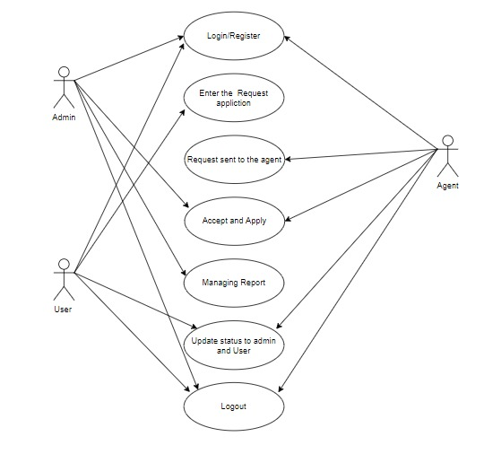

Context Diagram:

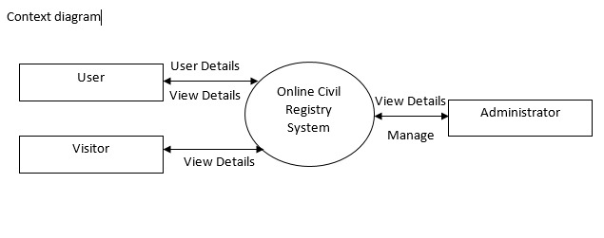

APPENDIX B- DATATABLES

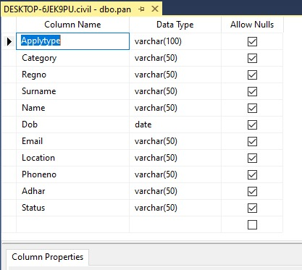

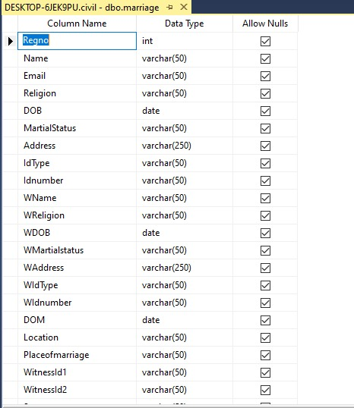

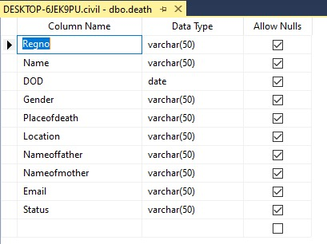

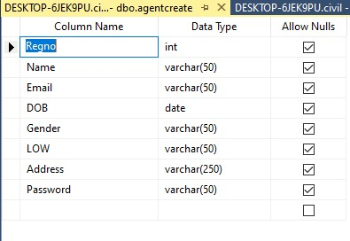

APPENDIX C- SCREENSHOTS

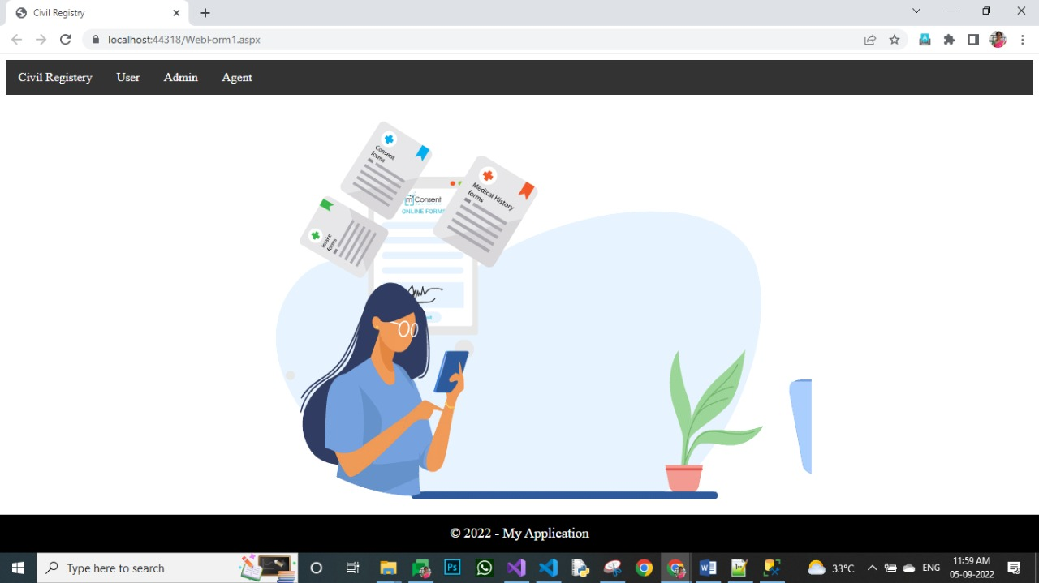

Admin Home page:

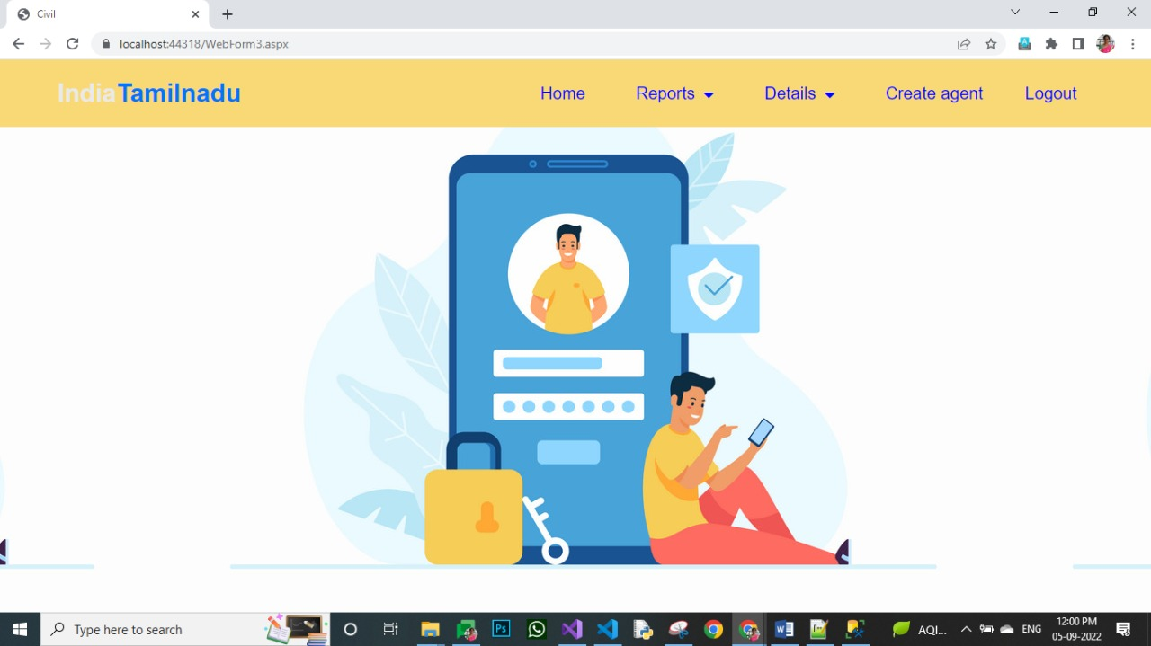

User Home page:

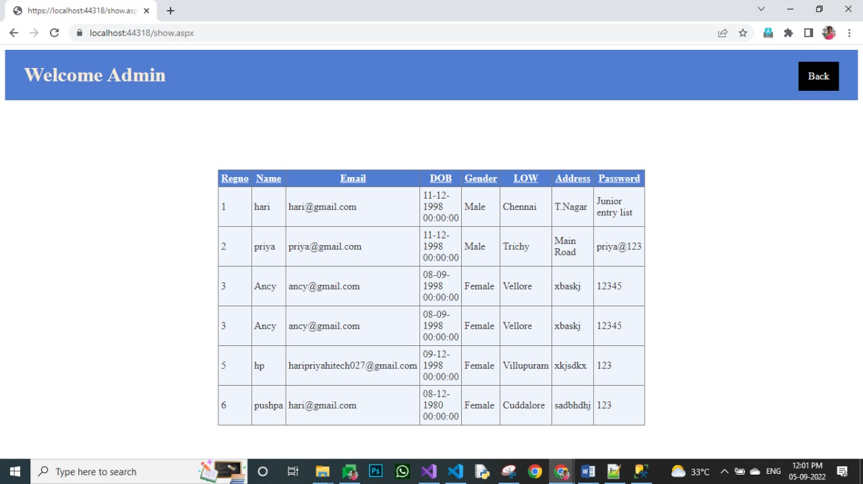

Admin Report Page:

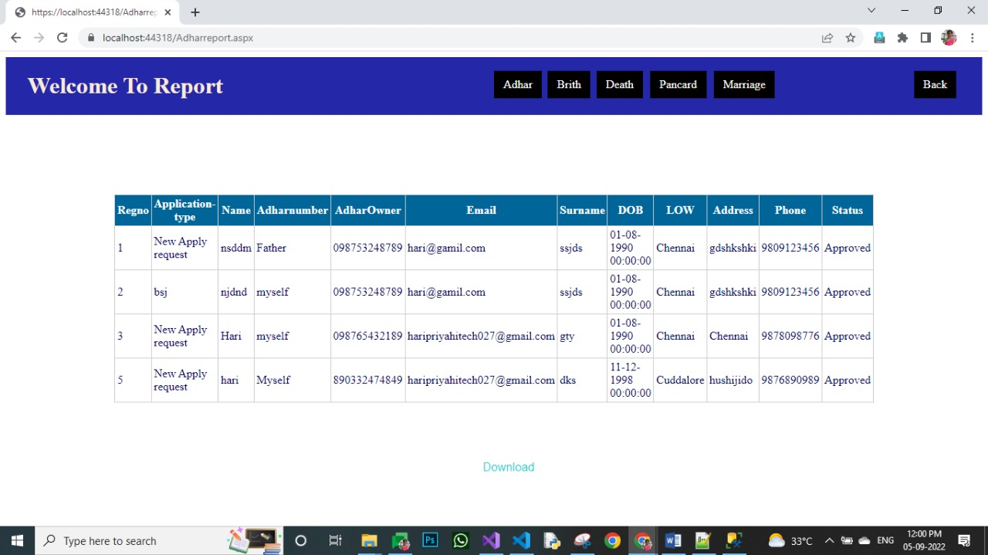

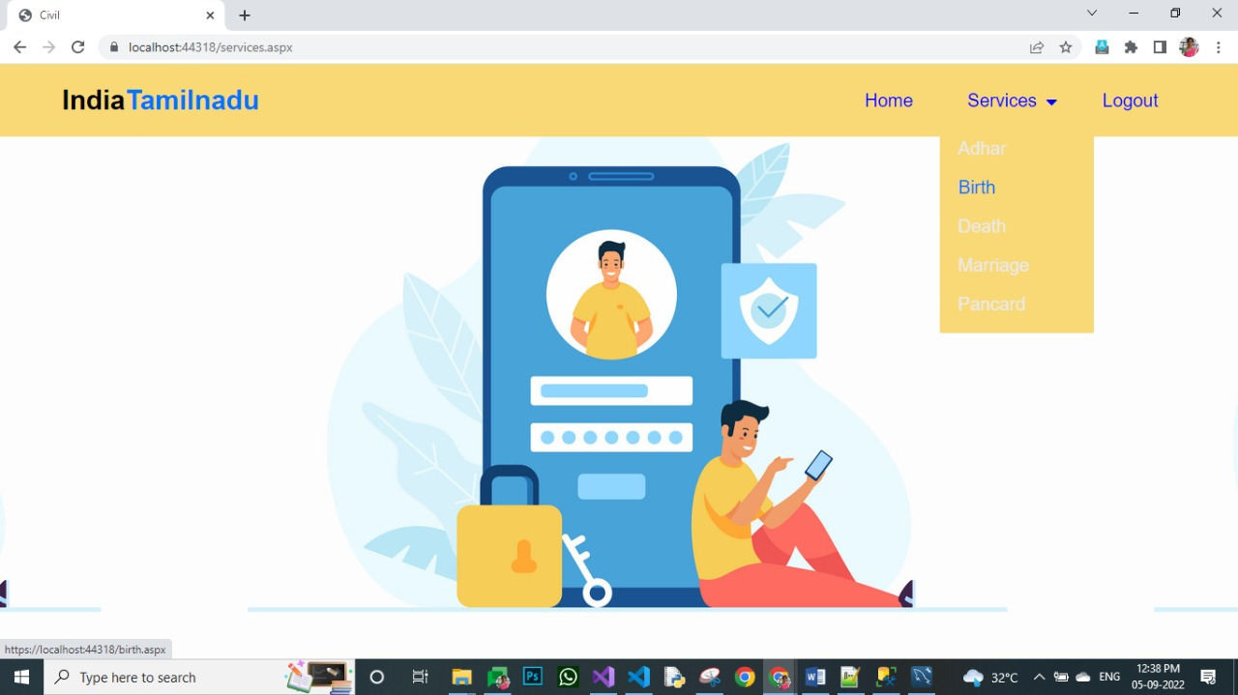

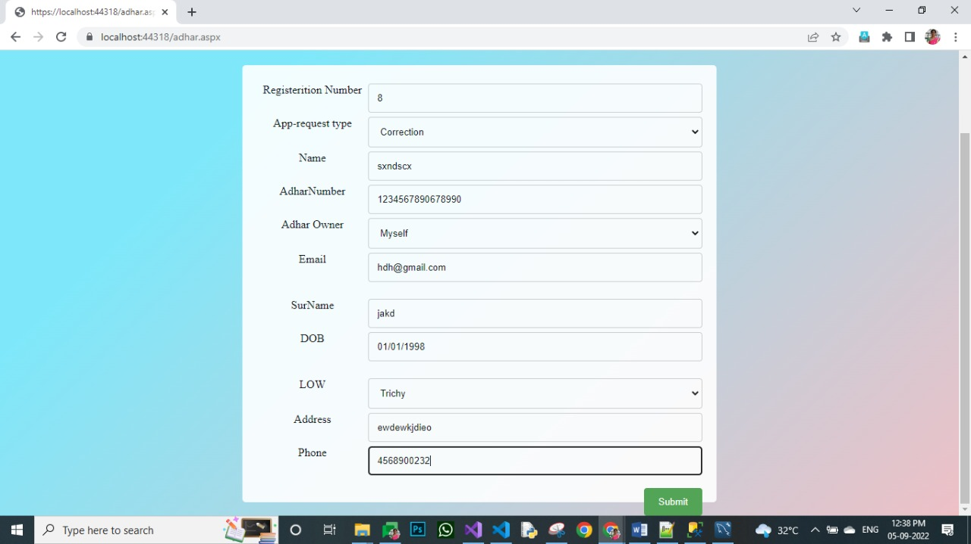

Agent Page: 